**REQUIREMENT INCEPTION**

**WIRELESS SENSOR NETWORK**

**(WSN)**

**HEALTH MONITORING SYSTEM**

Submitted By:

PC Mati Ur Rab

NC Maira Rahman

NC Mashood Tanveer

**CONTENTS**

1. Contents of the document are as followed:-
   1. Existing System
   2. Problem definition by gaining agreement of stakeholders
   3. Understand and illustrate the root causes
   4. Identify the stakeholders
   5. Define the solution system vision and boundary
   6. Identify the constraints to be imposed on the solution

**REQUIREMENT INCEPTION**

**EXISTING SYSTEM:**

The Wireless Sensor Network (WSN) Health Monitoring System is a system that provides an intelligent, reliable and un-intrusive health monitoring services. The WSN Health Monitoring System makes use of the services of a microscopic sensor that is injected into the patient’s body. This sensor monitors the patient’s vitals such as temperature, heart rate, blood pressure etc. The WSN Health Monitoring System also uses the services of a Bluetooth enabled wrist band which the patient should wear round the clock. In case of any abnormality in the readings, the wrist band raises an alarm (a beeping sound) thus informing the patient that there’s something wrong. Therefore the patient can take necessary precautions such as taking his medicines, going to a hospital etc.

For example, consider a person with heart problems, who has been injected with a sensor to keep track of the heart’s working. If the patient starts to go into cardiac arrest, the wrist band will warn him beforehand of the arriving problem and he can take his medicine.

**Problem definition by gaining agreement of stakeholders**

**PROBLEM STATEMENT:**

Currently, the existing system uses the sensor to monitor the vitals of a patient using a wrist band to raise alarm for any abnormality in normal behavior. But there is no way to save this data to a centralized database or to transfer this data to a doctor. Thus if the patient’s health continue to deteriorate in spite of the taken medicine, by the time he’s taken to a hospital, he might die. This could have been avoided if there had been a way to inform the doctor that his patient was not feeling well. Even if the patient reached the hospital somehow, he may not be able to give his history preventing the doctor from taking an immediate action. Similarly this could have been avoided if the database had the hourly based generated reports of the patient’s vitals.

**Understand and illustrate the root causes**

The root causes of the problem are:-

* **Patient**

|  |  |
| --- | --- |
| **Elements** | **Description** |
| The problem | 1. In case of unconsciousness, patient is unable to communicate his state. 2. No emergency backup available. 3. No immediate action taken due to lack of database |
| Affects | Patients. |
| Results | Death of a person |
| Benefits | 1. An hourly history of a patient is maintained. 2. Immediate help given to the patient 3. Patient’s life can be saved 4. Patient can easily be monitored by the doctor. |

* **Doctors**

|  |  |
| --- | --- |
| **Elements** | **Description** |
| The problem | History of patient is not available. |
| Affects | Doctors |
| Results | No immediate action can be taken |
| Benefits | 1. Doctors can keep track of his patient’s health from anywhere anytime. 2. Doctors can start immediate treatment |

**Identify the stakeholders**

Stakeholders are the people who are affected by the system in any way.

The stakeholders for the system are:-

1. Patients
2. Doctors
3. Doctor’s Federation
4. Organization
5. Organization’s shareholders
6. Mobile Vendors (who may want to install our software as a permanent application)
7. Marketing Manager

**Define the solution system vision and boundary**

**Context Diagram:**

The context diagram for the proposed system is as follows:

**WSN HEALTH MONITORING SYSTEM**

**System Boundary**

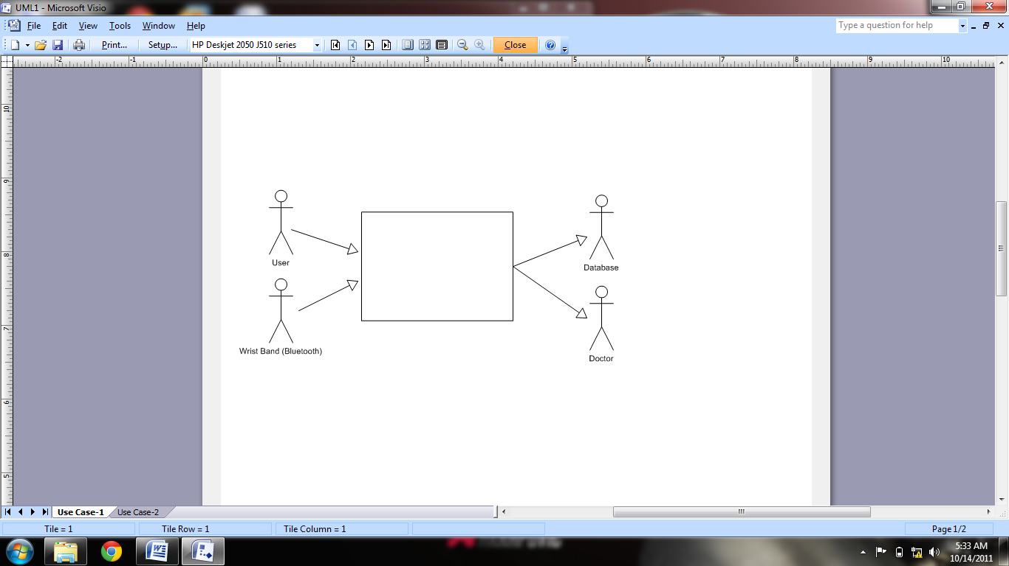

**Identify the constraints to be imposed on the solution**

The constraints on the proposed system are:-

|  |  |
| --- | --- |
| **Description** | **Rationale** |
| Android Mobile Operating System will be used. | Open APIs are available. |
| Java will be used as programming language. | Java applications are compatible with most of modern mobile phones. (Java is compatible Android Operating System). |
| Application Program Interface (API) of Android will be used. | Ease in using built in functions of Android. |
| The team would adopt OO-based methodologies. | These technologies will provide increased productivity and robustness. |